**EARTHQUAKEPREDICTIONSYSTEM**

**INTRODUCTION:**

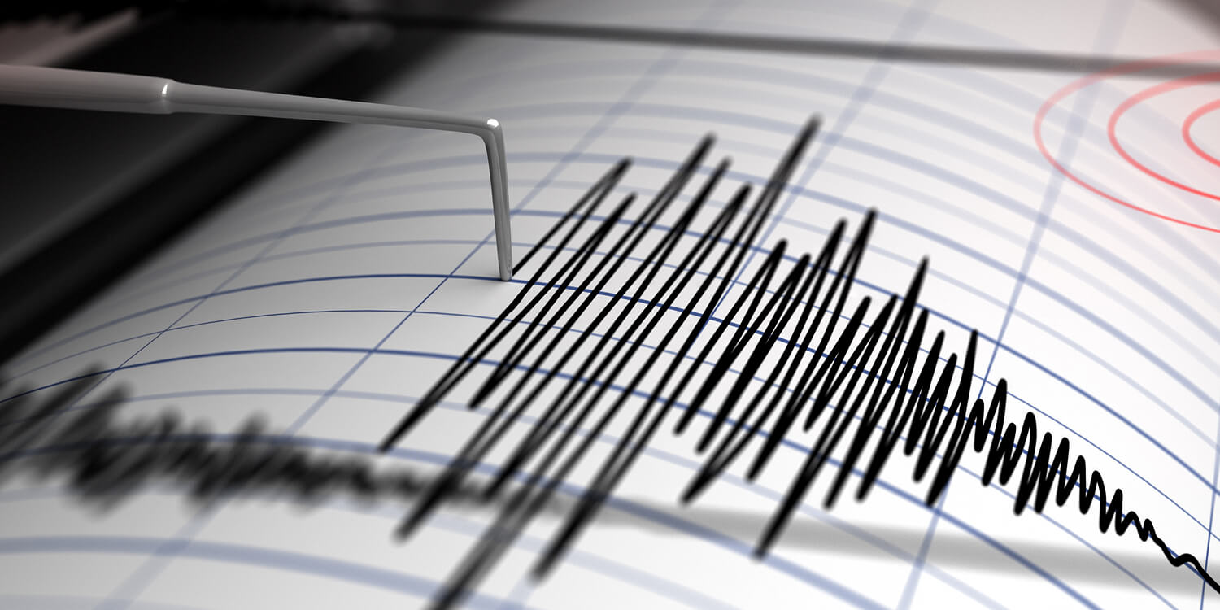

**EARTHQUAKE**

Earthquake prediction is a complex and challenging endeavor that has eluded scientists for many years. While there have been significant advancements in understanding seismic activity and monitoring, predicting the exact time, location, and magnitude of earthquakes remains highly uncertain. Here are some key points to consider when discussing earthquake prediction systems:

Seismic Monitoring:

Earthquake prediction systems heavily rely on monitoring seismic activity. Seismometers are placed strategically around fault lines and tectonic plate boundaries to record ground motion. By analyzing the data from these instruments, scientists can gain insights into the patterns and behaviors of earthquakes.

Seismic monitoring is the process of continuously recording and analyzing ground motion and vibrations caused by seismic activity, including earthquakes, volcanic eruptions, and other geological events. It plays a crucial role in understanding and studying these natural phenomena, assessing seismic hazards, and providing early warning systems to mitigate potential risks. Here's an exploration of seismic monitoring

## Seismometers:

Seismometers, also known as seismographs, are the primary instruments used in seismic monitoring. These devices are designed to detect ground motion by measuring the velocity or acceleration of ground vibrations. Seismometers consist of a mass suspended on a spring or pendulum, with a stationary frame attached to the Earth's surface. When an earthquake or other seismic event occurs, the ground motion causes the frame to move relative to the suspended mass, producing a recordable signal.

## Seismic Sensor Networks:

Seismometers are typically deployed in networks, strategically placed in regions prone to seismic activity. These networks provide comprehensive coverage and allow for the monitoring of seismic events in real time. Data from multiple seismometers can be used to triangulate the location and depth of an earthquake's epicenter.

## Data Analysis:

The data collected by seismometers are transmitted to data centers for analysis. Seismologists use specialized software and algorithms to process and interpret the seismic data. They analyze factors such as the amplitude, frequency, and duration of ground motion to determine the earthquake's magnitude and location.

## Seismic Waves:

Seismic monitoring records various types of seismic waves generated by earthquakes, including Primary (P) waves, Secondary (S) waves, and surface waves. These waves travel at different speeds and have distinct characteristics, which provide valuable information about the earthquake's source and the Earth's subsurface structure.

## Early Warning Systems:

Seismic monitoring data can be used to develop early warning systems for earthquakes. These systems detect the initial P-wave of an earthquake, which travels faster than the more damaging S-wave and surface waves. When the P-wave is detected, alerts can be sent to warn people and trigger automatic shutdowns of critical infrastructure, allowing individuals to take cover and minimize potential damage.

## Volcano Monitoring:

Seismic monitoring is also crucial for monitoring volcanic activity. Changes in seismic patterns, such as increased seismicity or the emergence of harmonic tremors, can indicate volcanic unrest. Continuous monitoring can help predict eruptions and provide early warnings to nearby communities.

## Research and Understanding:

Seismic monitoring is essential for advancing our understanding of Earth's interior and the processes that lead to earthquakes and volcanic eruptions. Researchers use seismic data to study the Earth's internal structure, tectonic plate movements, and the behavior of faults and magma chambers.

## 1.8 International Collaboration:

Seismic monitoring is often conducted through international collaborations and organizations, such as the Global Seismographic Network (GSN) and regional seismic networks. These partnerships allow for the sharing of data and expertise on a global scale.

Precursors:

Researchers have been searching for precursors or warning signs that might precede a major earthquake. These precursors could include changes in groundwater levels, animal behavior, or electromagnetic signals. However, these signs are often inconsistent and not reliable indicators.

Precursors in the context of seismic activity and earthquake prediction refer to potential signals or phenomena that may occur before a significant earthquake. Scientists have long sought to identify reliable precursors as they could provide valuable warning signs before a destructive earthquake strikes. However, the search for consistent and reliable earthquake precursors has proven challenging, and many precursors remain a subject of ongoing research and debate. Here, we'll explore the concept of precursors in earthquake prediction:

## 1. Types of Earthquake Precursors:

### -Seismic Activity Changes:

One potential precursor is an increase in small seismic events (foreshocks) leading up to a larger earthquake (mainshock). However, not all earthquakes are preceded by foreshocks, making this an unreliable indicator.

### - Ground Deformation:

Monitoring ground deformation through techniques like GPS and satellite imagery can reveal stress accumulation along fault lines. Rapid or unusual ground deformation patterns may be considered a precursor, but they are often difficult to interpret accurately.

### -Changes in Groundwater Levels:

Some studies have suggested that fluctuations in groundwater levels, such as changes in well water levels or spring flow rates, could be precursors to earthquakes. However, this remains a subject of debate, as these changes can also be influenced by various factors unrelated to seismic activity.

### -Animal Behavior:

Anecdotal evidence has occasionally suggested that certain animals may exhibit unusual behavior before an earthquake. While this idea is intriguing, scientific studies on animal behavior as earthquake precursors have produced inconclusive results.

### - Electromagnetic Anomalies:

Some researchers have explored the possibility of electromagnetic anomalies, such as changes in radio wave propagation or magnetic field variations, as potential precursors. However, these signals are often weak and difficult to detect consistently.

## 2.Challenges and Controversies:

- One of the primary challenges in identifying earthquake precursors is the lack of consistency and predictability. Precursors, if they exist, may vary significantly from one earthquake to another.

- Earthquake prediction is further complicated by the fact that not all earthquakes exhibit precursors, and many earthquakes occur without any warning signs.

- The scientific community remains cautious when interpreting potential precursors, as they must be rigorously tested and verified to avoid false alarms.

## 3. Current State of Research:

- Ongoing research continues to explore the possibility of identifying reliable earthquake precursors using advanced monitoring techniques and data analysis.

- Machine learning and artificial intelligence are being used to analyze large datasets to search for patterns or anomalies that might serve as precursors.

- The focus of earthquake research has shifted more toward early warning systems and earthquake preparedness, as these approaches provide more practical means of mitigating earthquake-related risks.

Probability Models:

Some earthquake prediction efforts focus on probabilistic models. These models assess historical seismic data to estimate the likelihood of an earthquake occurring in a particular area within a certain timeframe. While this approach can provide useful information for earthquake preparedness, it is not a precise prediction of when an earthquake will occur.

Early Warning Systems:

Some regions prone to earthquakes have implemented early warning systems. These systems use real-time seismic data to provide seconds to minutes of warning before the shaking from an earthquake reaches a particular location. These warnings can be used to trigger automatic shutdowns of critical infrastructure or to alert the public to take cover.

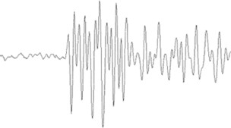

Machine Learning and AI:

Machine learning and artificial intelligence are being used to analyze seismic data and improve earthquake detection and early warning systems. These technologies can help process vast amounts of data more efficiently, potentially leading to better insights into seismic activity.

Challenges:

Earthquake prediction faces several challenges, including the complexity of the Earth's geological processes, the lack of consistent precursor signals, and the difficulty in replicating experimental results. The destructive nature of earthquakes also makes it ethically challenging to conduct large-scale experiments.

Focus on Preparedness:

Given the uncertainty surrounding earthquake prediction, efforts have increasingly shifted toward earthquake preparedness and risk mitigation. This involves designing buildings and infrastructure to withstand earthquakes, implementing early warning systems, and educating the public about earthquake safety measures.